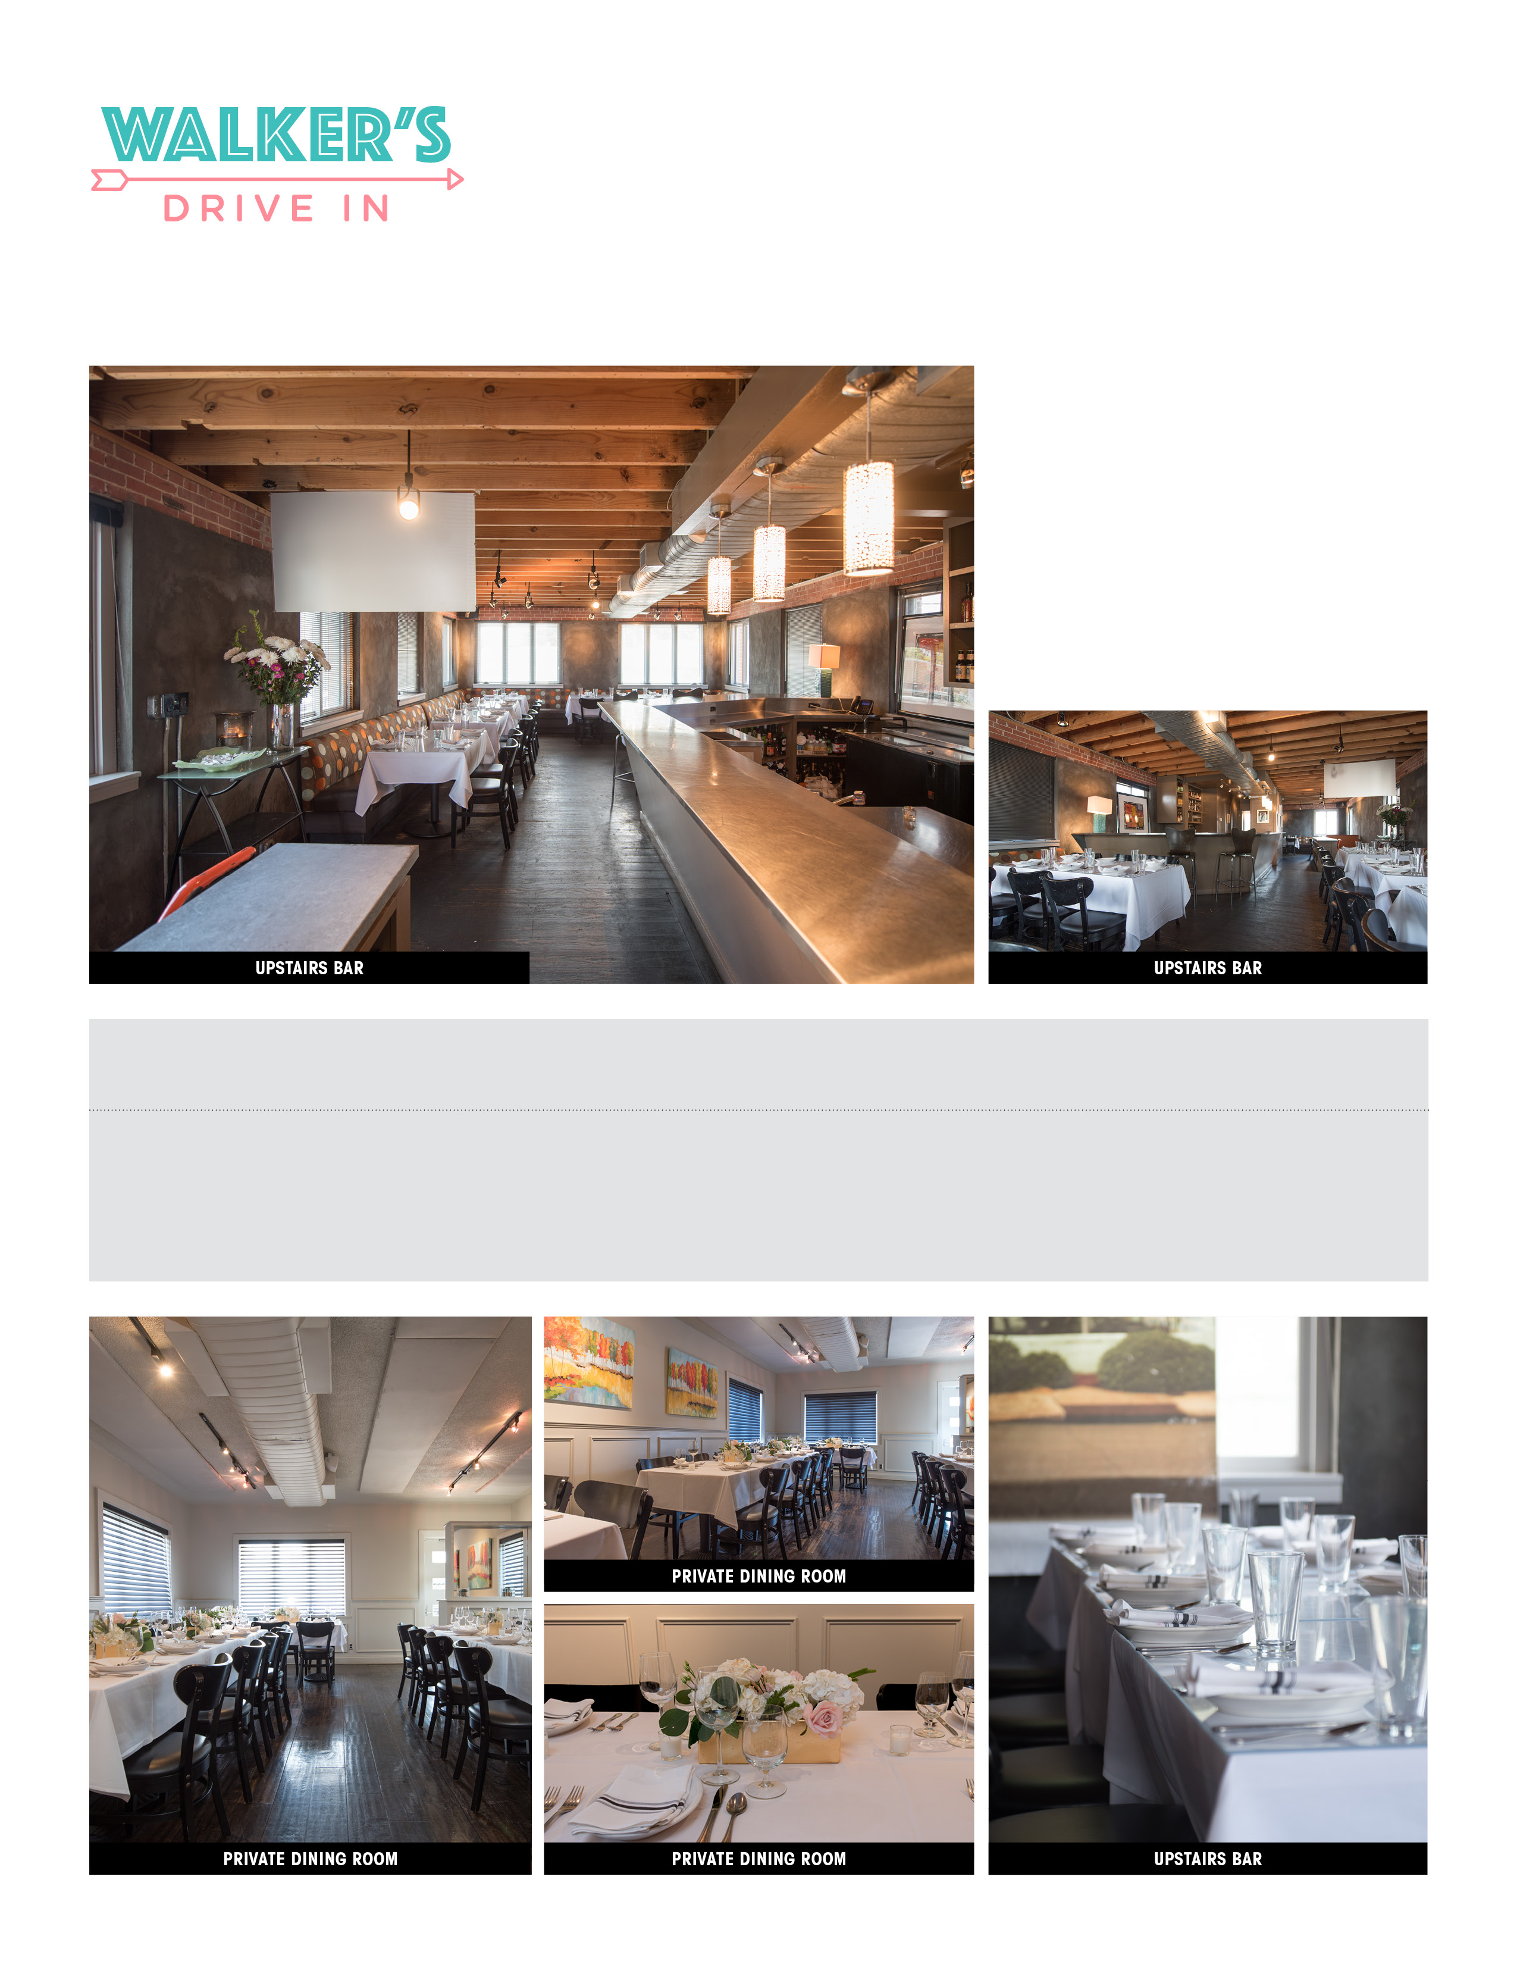

EVENT SPACE CAPACITY FOOD MINIMUM FOOD MINIMUM FOOD MINIMUM

SEATS/COCKTAIL MON-THU NIGHT FRI-SAT NIGHT MON-FRI LUNCH

Private Dining Room 48/55 $1200 $3000 $250

Upstairs Bar 48/70 $1200 $3000 $250

All minimums exclude tax and 20% gratuity.

WE ARE the specialists in fine dining for the metro area. we have you covered whether it’s Downtown Jackson, the Historic Fondren District, or Renaissance at Ridgeland. Our team will take care of all the details. Signature dishes from our great restaurants are available in all of our private dining rooms.

EFFIE HUBANKS

W. 601.982.2633

M. 601.906.3951

EFFIE@WALKERSDRIVEIN.COM